CHAPTER 5
Morphology of Flowering Plants
• Morphology of Flowering Plants

Profile | Katherine Esau (1898 - 1997)

Katherine Esau was born in Ukraine in 1898. She studied agriculture in Russia and Germany and received her doctorate in 1931 in United States. She reported in her early publications that the curly top virus spreads through a plant via the food-conducting or phloem tissue.
Dr Esau's Plant Anatomy, published in 1954, took a dynamic, developmental approach designed to enhance one's understanding of plant structure, and had an enormous impact worldwide, literally bringing about a revival of the discipline. The Anatomy of Seed Plants followed in 1960; it was referred to as Webster's of plant biology, being encyclopediac.
In 1957 she was elected to the National Academy of Sciences, becoming the sixth woman to receive that honour, and in 1989 she received the National Medal of Science from President George Bush. When Katherine Esau died in the year 1997, Peter Raven, director of Anatomy and Morphology, Missouri Botanical Garden, remembered that she 'absolutely dominated' the field of plant biology even at the age of 99.
5 | Morphology of Flowering Plants

• Root system and shoot system: the underground part of the flowering plant is the root system, while the portion above the ground forms the shoot system. The shoot system is differentiated into stem, leaves, flowers and fruits.
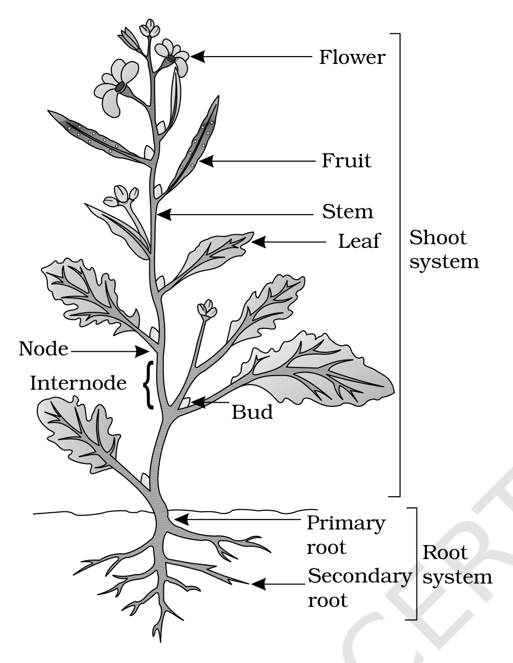
Fig. 5.1 - Parts of a flowering plant
Trace the plant from the ground up. The Root system below the soil carries a Primary root with its Secondary root branches. Above the soil the Shoot system carries the Stem, on which each Node bears a Leaf and a Bud, with an Internode between two successive nodes, and finally the Flower and the Fruit.
5.1 | The Root

In majority of the dicotyledonous plants, the direct elongation of the radicle leads to the formation of primary root which grows inside the soil. It bears lateral roots of several orders that are referred to as secondary, tertiary, etc. roots. The primary roots and its branches constitute the tap root system, as seen in the mustard plant.
In monocotyledonous plants, the primary root is short lived and is replaced by a large number of roots. These roots originate from the base of the stem and constitute the fibrous root system, as seen in the wheat plant. In some plants, like grass, Monstera and the banyan tree, roots arise from parts of the plant other than the radicle and are called adventitious roots.
Root system | Origin | Typical group | Example
Tap root system | Direct elongation of the radicle into a primary root bearing secondary, tertiary, etc. laterals | Majority of dicotyledonous plants | Mustard
Fibrous root system | Primary root short lived, replaced by a large number of roots from the base of the stem | Monocotyledonous plants | Wheat
Adventitious roots | Arise from parts of the plant other than the radicle | Both groups | Grass, Monstera, banyan tree

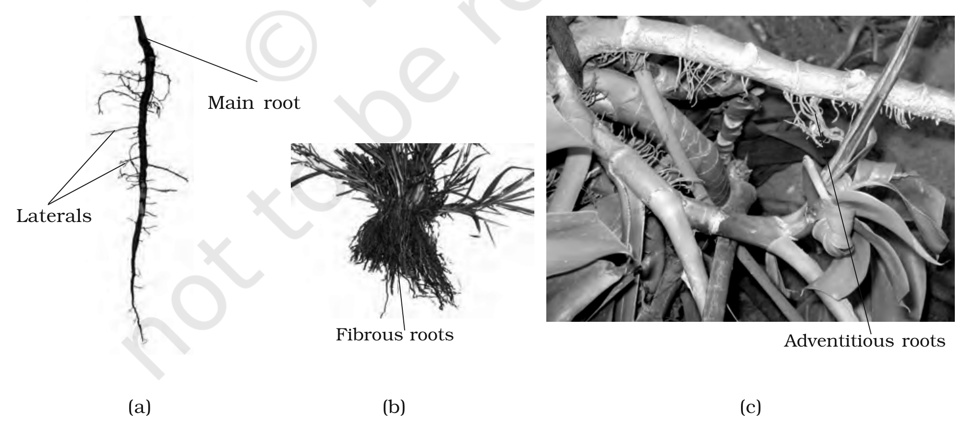
Fig. 5.2 - Different types of roots : (a) Tap (b) Fibrous (c) Adventitious
In the tap root the Main root is thickest and its branches are the Laterals; the wheat plant instead shows a cluster of Fibrous roots, and the third panel shows Adventitious roots arising away from the radicle.
The main functions of the root system are four: absorption of water and minerals from the soil, providing a proper anchorage to the plant parts, storing reserve food material, and synthesis of plant growth regulators. Beyond these, the roots in some plants get modified for storage of food, mechanical support and respiration.
5.1.1 | Regions of the Root

The root is covered at the apex by a thimble-like structure called the root cap, which protects the tender apex of the root as it makes its way through the soil. Moving back from the tip, the root passes through three successive regions.
1 | Region of meristematic activity - a few millimetres above the root cap. Its cells are very small, thin-walled and with dense protoplasm, and they divide repeatedly.
2 | Region of elongation - the cells proximal to the meristematic region undergo rapid elongation and enlargement, and are responsible for the growth of the root in length.
3 | Region of maturation - proximal to the region of elongation, the cells of the elongation zone gradually differentiate and mature. From this region some of the epidermal cells form very fine and delicate, thread-like structures called root hairs, which absorb water and minerals from the soil.

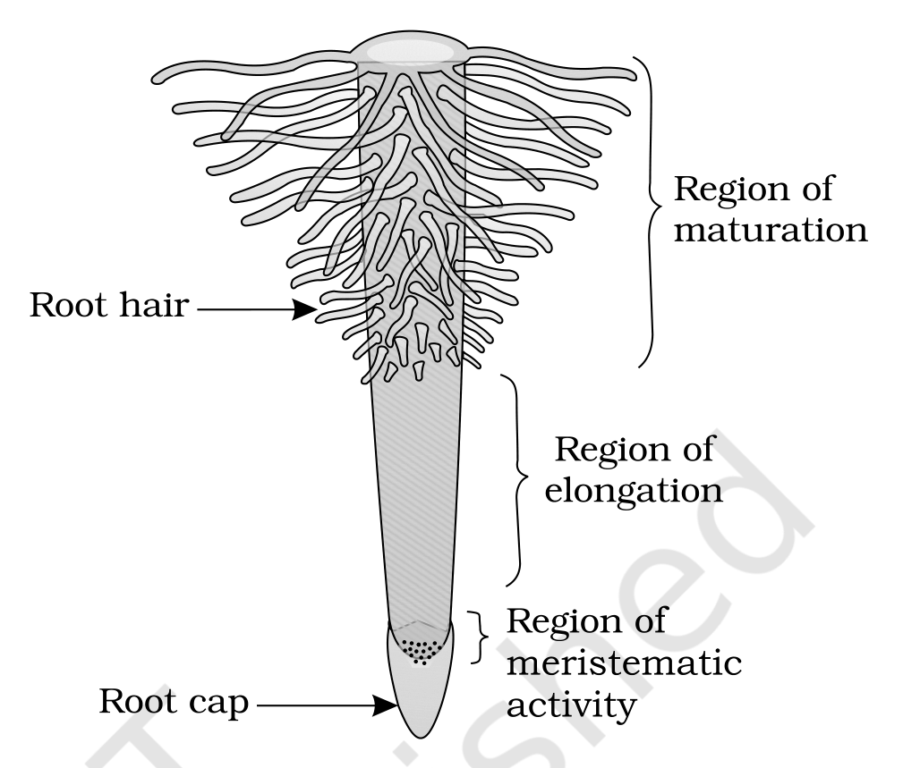
Fig. 5.3 - The regions of the root-tip
Read the plate from the tip upwards: Root cap, then the Region of meristematic activity, then the Region of elongation, and finally the Region of maturation, from which each Root hair emerges.
[NOTE] The three regions are a developmental sequence, not three different tissues: the same cell is first produced in the meristematic region, then elongates, then matures.

5.2 | The Stem

What are the features that distinguish a stem from a root? The morphological features of stems - the presence of nodes and internodes, multicellular hair and positively phototropic nature - help to differentiate the stems from roots.
• Stem: the ascending part of the axis bearing branches, leaves, flowers and fruits. It develops from the plumule of the embryo of a germinating seed.
• Node and internode: the region of the stem where leaves are born are called nodes, while internodes are the portions between two nodes.
The stem bears buds, which may be terminal or axillary. Stem is generally green when young and later often become woody and dark brown.
The main function of the stem is spreading out branches bearing leaves, flowers and fruits. It conducts water, minerals and photosynthates. Some stems perform the function of storage of food, support, protection and of vegetative propagation.
5.3 | The Leaf

The leaf is a lateral, generally flattened structure borne on the stem; it is a lateral outgrowth of stem developed exogeneously at the node. It develops at the node and bears a bud in its axil, and that axillary bud later develops into a branch. Leaves originate from shoot apical meristems and are arranged in an acropetal order. They are the most important vegetative organs for photosynthesis.
A typical leaf consists of three main parts: leaf base, petiole and lamina.
Part | Description
Leaf base | The leaf is attached to the stem by the leaf base and may bear two lateral small leaf like structures called stipules. In monocotyledons, the leaf base expands into a sheath covering the stem partially or wholly. In some leguminous plants the leafbase may become swollen, which is called the pulvinus.
Petiole | The petiole help hold the blade to light. Long thin flexible petioles allow leaf blades to flutter in wind, thereby cooling the leaf and bringing fresh air to leaf surface.
Lamina (leaf blade) | The green expanded part of the leaf with veins and veinlets. There is, usually, a middle prominent vein, which is known as the midrib. Veins provide rigidity to the leaf blade and act as channels of transport for water, minerals and food materials.

The shape, margin, apex, surface and extent of incision of lamina varies in different leaves.
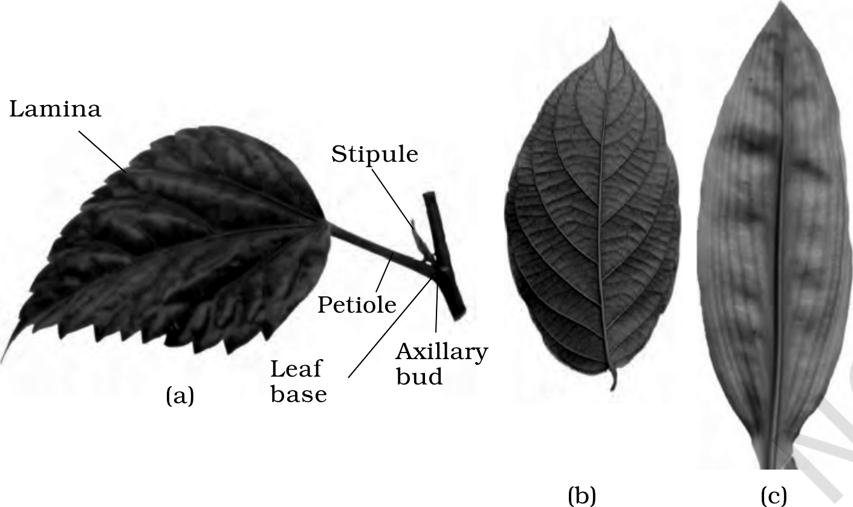
Fig. 5.4 - Structure of a leaf : (a) Parts of a leaf (b) Reticulate venation (c) Parallel venation
Panel (a) names the parts in order from the stem outwards: the Leaf base with its Stipule and the Axillary bud in the axil, then the Petiole, then the Lamina.
5.3.1 | Venation

• Venation: the arrangement of veins and the veinlets in the lamina of leaf.
Venation | Arrangement | Characteristic of
Reticulate | The veinlets form a network | Leaves of dicotyledonous plants generally
Parallel | The veins run parallel to each other within a lamina | Most monocotyledons

5.3.2 | Types of Leaves

A leaf is said to be simple when its lamina is entire, or when incised, the incisions do not touch the midrib. When the incisions of the lamina reach up to the midrib breaking it into a number of leaflets, the leaf is called compound.
[NOTE] A bud is present in the axil of petiole in both simple and compound leaves, but not in the axil of leaflets of the compound leaf. This is the test that separates a compound leaf from a branch bearing simple leaves.

The compound leaves may be of two types.
Compound leaf | Arrangement of leaflets | Example
Pinnately compound | A number of leaflets are present on a common axis, the rachis, which represents the midrib of the leaf | Neem
Palmately compound | The leaflets are attached at a common point, i.e., at the tip of petiole | Silk cotton

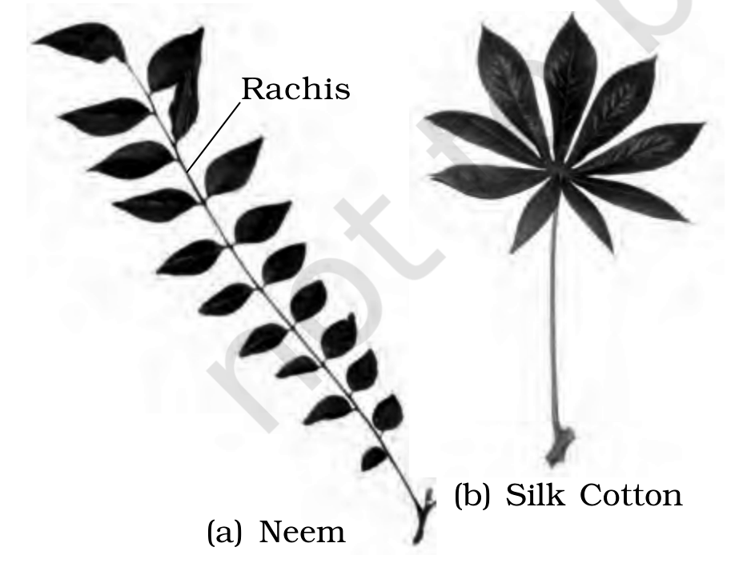
Fig. 5.5 - Compound leaves : (a) pinnately compound leaf (b) palmately compound leaf
In the pinnately compound leaf of Neem the leaflets sit along the Rachis; in the palmately compound leaf of Silk Cotton they radiate from the tip of the petiole.
5.3.3 | Phyllotaxy

• Phyllotaxy: the pattern of arrangement of leaves on the stem or branch.
This is usually of three types - alternate, opposite and whorled.
Type | Arrangement at a node | Examples
Alternate | A single leaf arises at each node in alternate manner | China rose, mustard and sun flower plants
Opposite | A pair of leaves arise at each node and lie opposite to each other | Calotropis and guava plants
Whorled | More than two leaves arise at a node and form a whorl | Alstonia

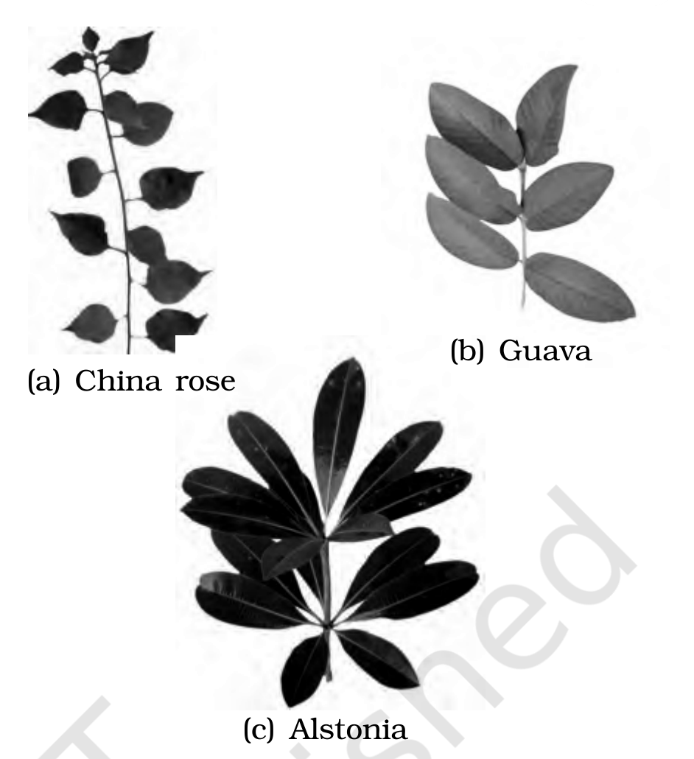
Fig. 5.6 - Different types of phyllotaxy : (a) Alternate (b) Opposite (c) Whorled
The three panels are drawn from China rose (alternate), Guava (opposite) and Alstonia (whorled).
5.4 | The Inflorescence

A flower is a modified shoot wherein the shoot apical meristem changes to floral meristem. Internodes do not elongate and the axis gets condensed. The apex produces different kinds of floral appendages laterally at successive nodes instead of leaves. When a shoot tip transforms into a flower, it is always solitary.
• Inflorescence: the arrangement of flowers on the floral axis.
Depending on whether the apex gets developed into a flower or continues to grow, two major types of inflorescences are defined - racemose and cymose.
Inflorescence | Fate of the main axis | Order in which flowers are borne
Racemose | The main axis continues to grow | Flowers are borne laterally in an acropetal succession
Cymose | The main axis terminates in a flower, hence is limited in growth | The flowers are borne in a basipetal order

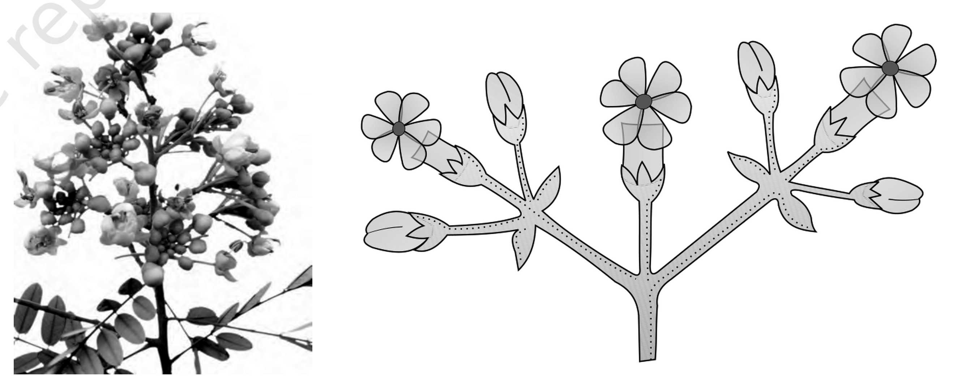
Figs. 5.7-5.8 - (5.7) Racemose inflorescence; (5.8) Cymose inflorescence
[MEMORY AID - not in NCERT] Acropetal points to the apex, so the youngest flower is at the top and the axis is still growing - that is racemose. Basipetal runs the other way, towards the base, because the tip was used up by the first flower - that is cymose.

5.5 | The Flower

The flower is the reproductive unit in the angiosperms. It is meant for sexual reproduction. A typical flower has four different kinds of whorls arranged successively on the swollen end of the stalk or pedicel, called thalamus or receptacle. These are calyx, corolla, androecium and gynoecium. Calyx and corolla are accessory organs, while androecium and gynoecium are reproductive organs. In some flowers like lily, the calyx and corolla are not distinct and are termed as perianth.
When a flower has both androecium and gynoecium, it is bisexual. A flower having either only stamens or only carpels is unisexual.
In symmetry, the flower may be actinomorphic (radial symmetry) or zygomorphic (bilateral symmetry).
Symmetry | Test | Examples
Actinomorphic (radial) | Can be divided into two equal radial halves in any radial plane passing through the centre | Mustard, datura, chilli
Zygomorphic (bilateral) | Can be divided into two similar halves only in one particular vertical plane | Pea, gulmohur, bean, Cassia
Asymmetric (irregular) | Cannot be divided into two similar halves by any vertical plane passing through the centre | Canna

A flower may be trimerous, tetramerous or pentamerous when the floral appendages are in multiple of 3, 4 or 5, respectively. Flowers with bracts - reduced leaf found at the base of the pedicel - are called bracteate and those without bracts, ebracteate.
Based on the position of calyx, corolla and androecium in respect of the ovary on thalamus, the flowers are described as hypogynous, perigynous and epigynous.
Flower | Position of parts | Ovary is said to be | Examples
Hypogynous | The gynoecium occupies the highest position while the other parts are situated below it | Superior | Mustard, china rose, brinjal
Perigynous | Gynoecium is situated in the centre and other parts of the flower are located on the rim of the thalamus almost at the same level | Half inferior | Plum, rose, peach
Epigynous | The margin of thalamus grows upward enclosing the ovary completely and getting fused with it, the other parts of flower arise above the ovary | Inferior | Guava, cucumber, and the ray florets of sunflower

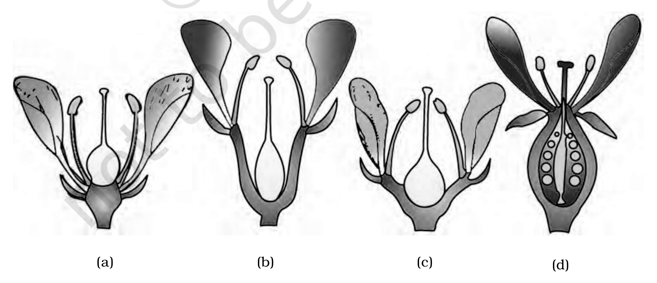
Fig. 5.9 - Position of floral parts on thalamus : (a) Hypogynous (b) and (c) Perigynous (d) Epigynous
5.5.1 | Parts of a Flower

Each flower normally has four floral whorls, viz., calyx, corolla, androecium and gynoecium.
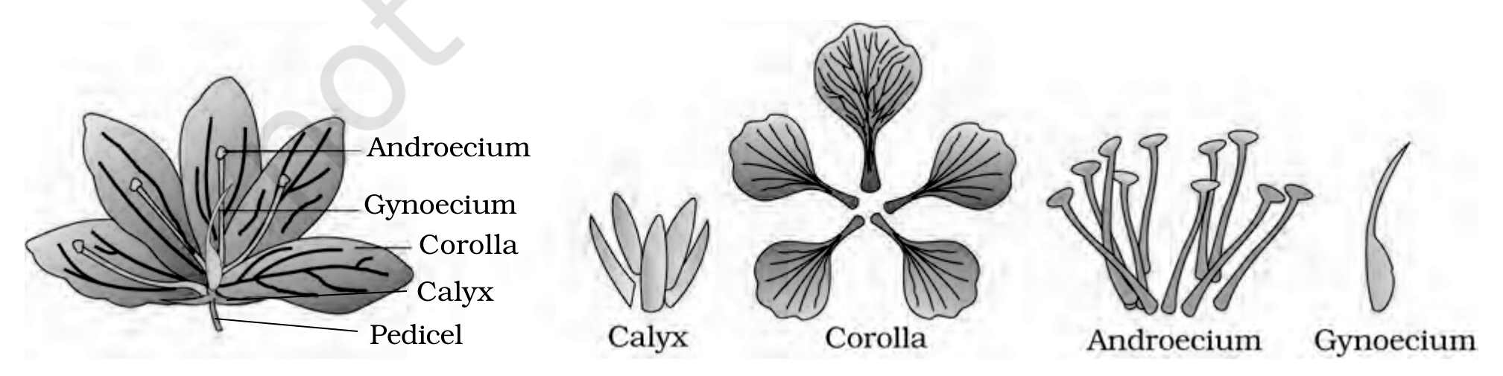
Fig. 5.10 - Parts of a flower
Working inwards from the stalk: the Pedicel carries the Calyx, then the Corolla, then the Androecium, with the Gynoecium at the centre.
5.5.1.1 | Calyx

The calyx is the outermost whorl of the flower and the members are called sepals. Generally, sepals are green, leaf like and protect the flower in the bud stage. The calyx may be gamosepalous (sepals united) or polysepalous (sepals free).
5.5.1.2 | Corolla

Corolla is composed of petals. Petals are usually brightly coloured to attract insects for pollination. Like calyx, corolla may also be gamopetalous (petals united) or polypetalous (petals free). The shape and colour of corolla vary greatly in plants: corolla may be tubular, bell-shaped, funnel-shaped or wheel-shaped.
• Aestivation: the mode of arrangement of sepals or petals in floral bud with respect to the other members of the same whorl.
The main types of aestivation are valvate, twisted, imbricate and vexillary.
Aestivation | Arrangement in the bud | Examples
Valvate | Sepals or petals in a whorl just touch one another at the margin, without overlapping | Calotropis
Twisted | One margin of the appendage overlaps that of the next one and so on | China rose, lady's finger, cotton
Imbricate | The margins of sepals or petals overlap one another but not in any particular direction | Cassia, gulmohur
Vexillary (papilionaceous) | Of five petals, the largest (standard) overlaps the two lateral petals (wings), which in turn overlap the two smallest anterior petals (keel) | Pea, bean

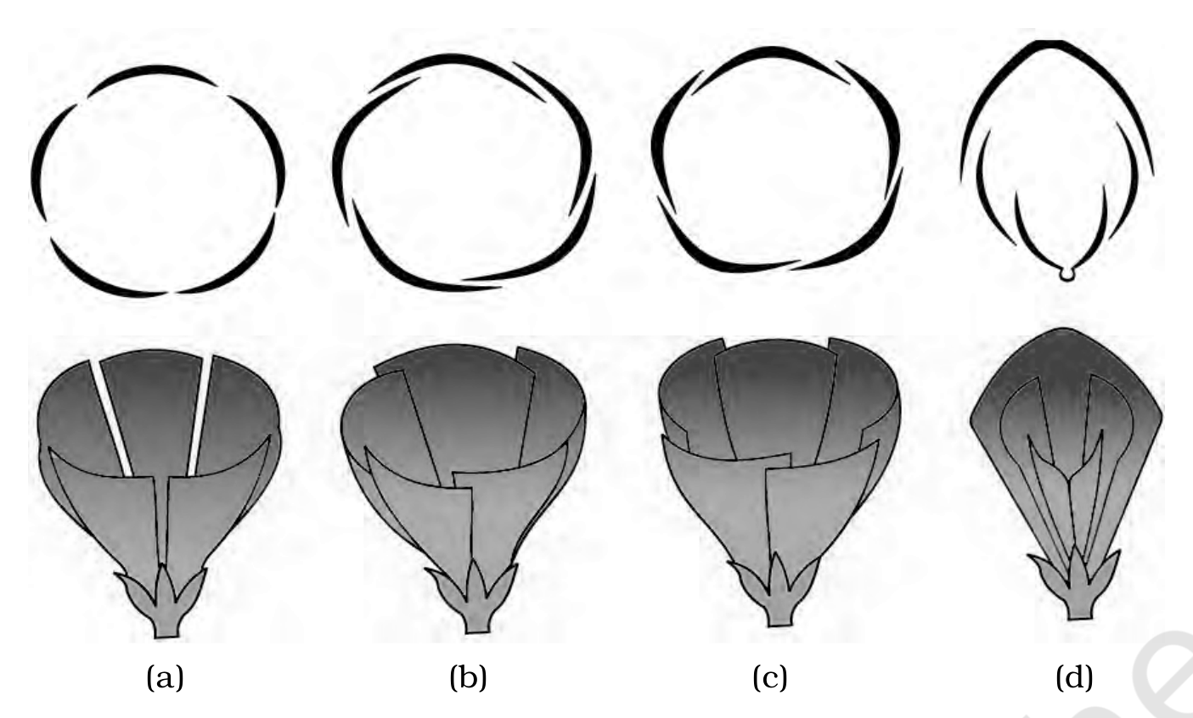
Fig. 5.11 - Types of aestivation in corolla : (a) Valvate (b) Twisted (c) Imbricate (d) Vexillary
5.5.1.3 | Androecium

Androecium is composed of stamens. Each stamen, which represents the male reproductive organ, consists of a stalk or a filament and an anther. Each anther is usually bilobed and each lobe has two chambers, the pollen-sacs; the pollen grains are produced in pollen-sacs. A sterile stamen is called staminode.
Stamens of flower may be united with other members such as petals or among themselves.
Condition | Union | Example
Epipetalous | Stamens are attached to the petals | Brinjal
Epiphyllous | Stamens attached to the perianth | Lily
Polyandrous | The stamens remain free | N/A
Monoadelphous | Stamens united into one bunch or one bundle | China rose
Diadelphous | Stamens united into two bundles | Pea
Polyadelphous | Stamens united into more than two bundles | Citrus

There may be a variation in the length of filaments within a flower, as in Salvia and mustard.
5.5.1.4 | Gynoecium

Gynoecium is the female reproductive part of the flower and is made up of one or more carpels. A carpel consists of three parts namely stigma, style and ovary. Ovary is the enlarged basal part, on which lies the elongated tube, the style. The style connects the ovary to the stigma. The stigma is usually at the tip of the style and is the receptive surface for pollen grains. Each ovary bears one or more ovules attached to a flattened, cushion-like placenta.
When more than one carpel is present, they may be free (as in lotus and rose) and are called apocarpous. They are termed syncarpous when carpels are fused, as in mustard and tomato.
1 | Fertilisation takes place in the ovule inside the ovary.
2 | After fertilisation, the ovules develop into seeds.
3 | The ovary matures into a fruit.

• Placentation: the arrangement of ovules within the ovary.
The placentation are of different types namely, marginal, axile, parietal, basal, central and free central.
Placentation | Arrangement of ovules | Examples
Marginal | The placenta forms a ridge along the ventral suture of the ovary and the ovules are borne on this ridge forming two rows | Pea
Axile | The placenta is axial and the ovules are attached to it in a multilocular ovary | China rose, tomato, lemon
Parietal | The ovules develop on the inner wall of the ovary or on peripheral part; ovary is one-chambered but it becomes two-chambered due to the formation of the false septum | Mustard, Argemone
Free central | The ovules are borne on central axis and septa are absent | Dianthus, Primrose
Basal | The placenta develops at the base of ovary and a single ovule is attached to it | Sunflower, marigold

[NOTE] The chapter names six types in its list - marginal, axile, parietal, basal, central and free central - but defines and figures five: central placentation is named and never explained. Both the six-name list and the five definitions are reproduced here exactly as the source gives them.

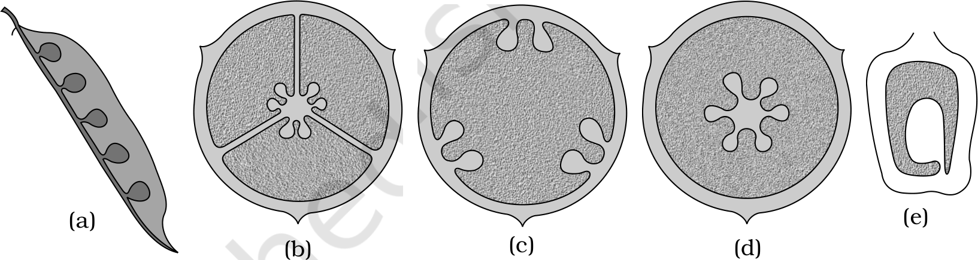
Fig. 5.12 - Types of placentation : (a) Marginal (b) Axile (c) Parietal (d) Free central (e) Basal
5.6 | The Fruit

The fruit is a characteristic feature of the flowering plants. It is a mature or ripened ovary, developed after fertilisation. If a fruit is formed without fertilisation of the ovary, it is called a parthenocarpic fruit.
Generally, the fruit consists of a wall or pericarp and seeds. The pericarp may be dry or fleshy. When pericarp is thick and fleshy, it is differentiated into the outer epicarp, the middle mesocarp and the inner endocarp.
In mango and coconut, the fruit is known as a drupe. They develop from monocarpellary superior ovaries and are one seeded. In mango the pericarp is well differentiated into an outer thin epicarp, a middle fleshy edible mesocarp and an inner stony hard endocarp. In coconut, which is also a drupe, the mesocarp is fibrous.
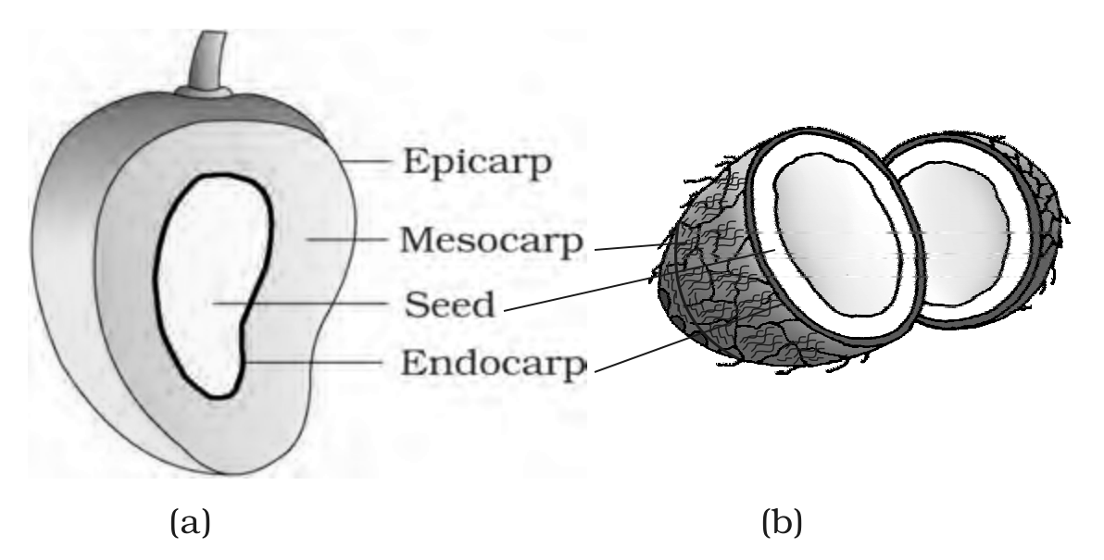
Fig. 5.13 - Parts of a fruit : (a) Mango (b) Coconut
Both panels are labelled from the outside inwards - Epicarp, Mesocarp, Endocarp - with the Seed enclosed within.
5.7 | The Seed

The ovules after fertilisation, develop into seeds. A seed is made up of a seed coat and an embryo. The embryo is made up of a radicle, an embryonal axis and one (as in wheat, maize) or two cotyledons (as in gram and pea). Seeds vary in shape, size and period of viability.
5.7.1 | Structure of a Dicotyledonous Seed

The outermost covering of a seed is the seed coat. The seed coat has two layers, the outer testa and the inner tegmen. The hilum is a scar on the seed coat through which the developing seeds were attached to the fruit. Above the hilum is a small pore called the micropyle.
Within the seed coat is the embryo, consisting of an embryonal axis and two cotyledons. The cotyledons are often fleshy and full of reserve food materials. At the two ends of the embryonal axis are present the radicle and the plumule.
In some seeds such as castor the endosperm, formed as a result of double fertilisation, is a food storing tissue and such seeds are called endospermic seeds. In plants such as bean, gram and pea, the endosperm is not present in mature seeds and such seeds are called non-endospermous.
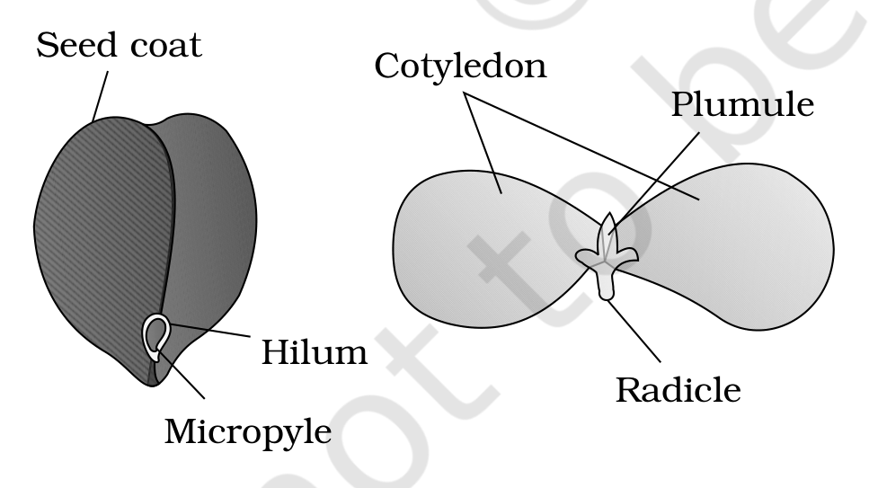
Fig. 5.14 - Structure of dicotyledonous seed
The plate labels the Seed coat with the Hilum and Micropyle on it, the fleshy Cotyledon, and the two ends of the embryonal axis, the Plumule and the Radicle.
5.7.2 | Structure of Monocotyledonous Seed

Generally, monocotyledonous seeds are endospermic but some as in orchids are non-endospermic. In the seeds of cereals such as maize the seed coat is membranous and generally fused with the fruit wall. The endosperm is bulky and stores food. The outer covering of endosperm separates the embryo by a proteinous layer called aleurone layer.
The embryo is small and situated in a groove at one end of the endosperm. It consists of one large and shield shaped cotyledon known as scutellum and a short axis with a plumule and a radicle. The plumule and radicle are enclosed in sheaths which are called coleoptile and coleorhiza respectively.
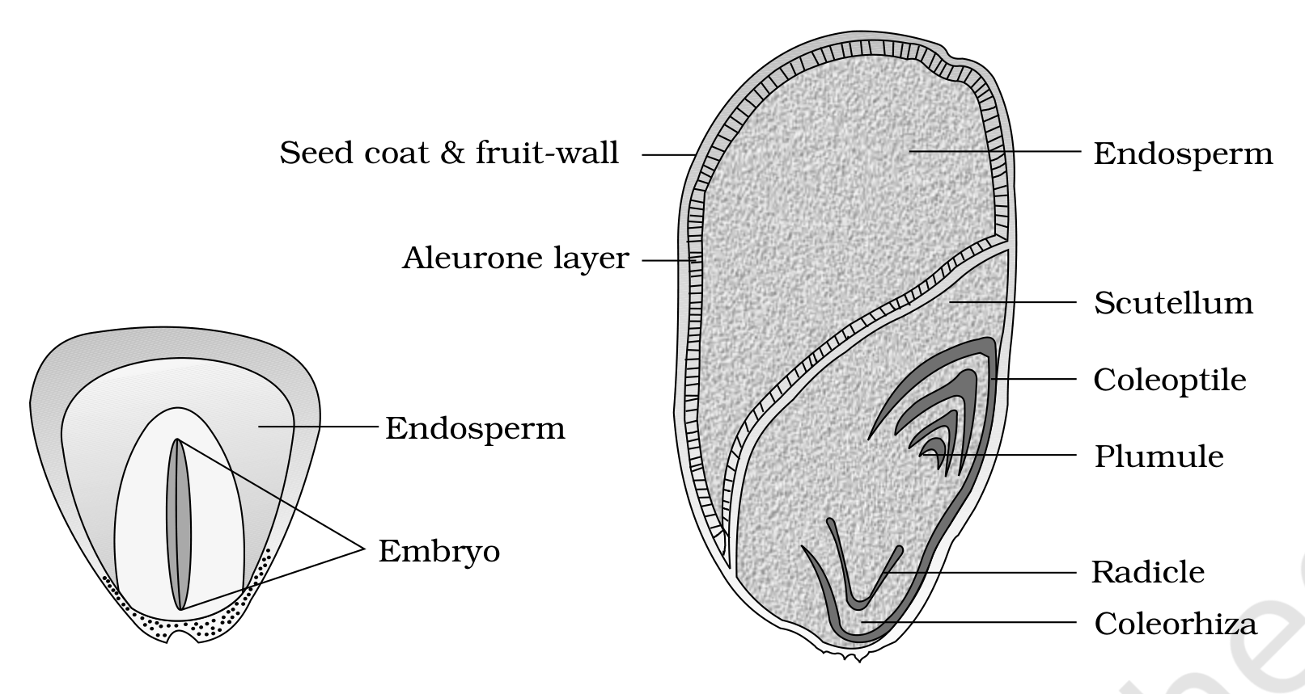
Fig. 5.15 - Structure of a monocotyledonous seed
The labelled parts are the Seed coat & fruit-wall, the Aleurone layer, the bulky Endosperm, the shield-shaped Scutellum, and the Embryo itself, whose Plumule is sheathed by the Coleoptile and whose Radicle is sheathed by the Coleorhiza.
Feature | Dicotyledonous seed | Monocotyledonous seed
Seed coat | Two layers, outer testa and inner tegmen | Membranous and generally fused with the fruit wall (cereals such as maize)
Cotyledons | Two, often fleshy and full of reserve food materials | One large and shield shaped, known as scutellum
Endosperm | Present in endospermic seeds such as castor; absent in non-endospermous seeds such as bean, gram and pea | Generally endospermic and bulky, storing food; some, as in orchids, are non-endospermic
Protective sheaths | N/A | Plumule and radicle enclosed in coleoptile and coleorhiza respectively
Special layer | N/A | Aleurone layer, a proteinous layer separating endosperm from embryo

5.8 | Semi-technical Description of a Typical Flowering Plant

Various morphological features are used to describe a flowering plant. The floral characteristics form the basis of classification and identification of flowering plants. The description has to be brief, in a simple and scientific language and presented in a proper sequence.
1 | Describe the habit of the plant.
2 | Describe the vegetative characters - roots, stem and leaves.
3 | Describe the floral characters - inflorescence and flower parts.
4 | Present a floral diagram and a floral formula.

The floral formula is represented by some symbols.
Symbol | Stands for
Br | Bracteate
K | Calyx
C | Corolla
P | Perianth
A | Androecium
G | Gynoecium
G with a line drawn beneath it | Superior ovary
G with a line drawn above it | Inferior ovary
Male symbol | Male
Female symbol | Female
Combined male-female symbol | Bisexual plants
Circled-plus symbol | Actinomorphic
Per-cent symbol | Zygomorphic nature of flower

Fusion is indicated by enclosing the figure within bracket and adhesion by a line drawn above the symbols of the floral parts.
A floral diagram provides information about the number of parts of a flower, their arrangement and the relation they have with one another. The position of the mother axis with respect to the flower is represented by a dot on the top of the floral diagram. Calyx, corolla, androecium and gynoecium are drawn in successive whorls, calyx being the outermost and the gynoecium being in the centre. Floral formula also shows cohesion and adhesion within parts of whorls and between whorls.
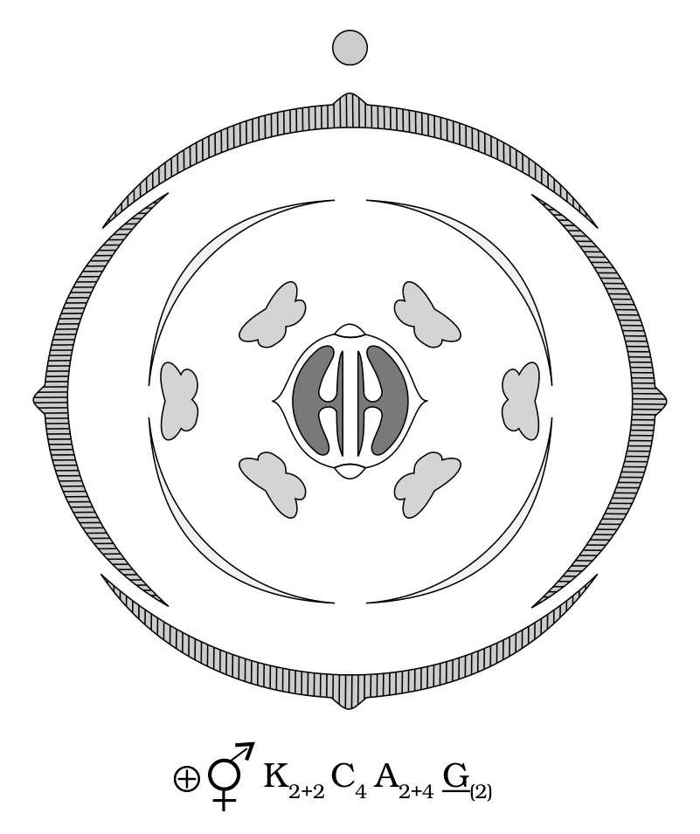
Fig. 5.16 - Floral diagram with floral formula
The floral diagram and floral formula in this plate represents the mustard plant (Family: Brassicaceae), whose printed formula reads K2+2 C4 A2+4 G(2).
5.9 | Solanaceae

Solanaceae is a large family, commonly called as the 'potato family'. It is widely distributed in tropics, subtropics and even temperate zones.
Vegetative | Vegetative Characters

Field | Description
Habit | Plants mostly herbs, shrubs and rarely small trees
Stem | Herbaceous rarely woody, aerial; erect, cylindrical, branched, solid or hollow, hairy or glabrous, underground stem in potato (Solanum tuberosum)
Leaves | Alternate, simple, rarely pinnately compound, exstipulate; venation reticulate

Floral | Floral Characters

Field | Description
Inflorescence | Solitary, axillary or cymose as in Solanum
Flower | Bisexual, actinomorphic
Calyx | Sepals five, united, persistent, valvate aestivation
Corolla | Petals five, united; valvate aestivation
Androecium | Stamens five, epipetalous
Gynoecium | Bicarpellary obligately placed, syncarpous; ovary superior, bilocular, placenta swollen with many ovules, axile
Fruits | Berry or capsule
Seeds | Many, endospermous

Floral Formula: circled-plus symbol, bisexual symbol, K(5) C(5) A5 G(2), with an adhesion arc drawn over the corolla and androecium and a line beneath the G for the superior ovary.
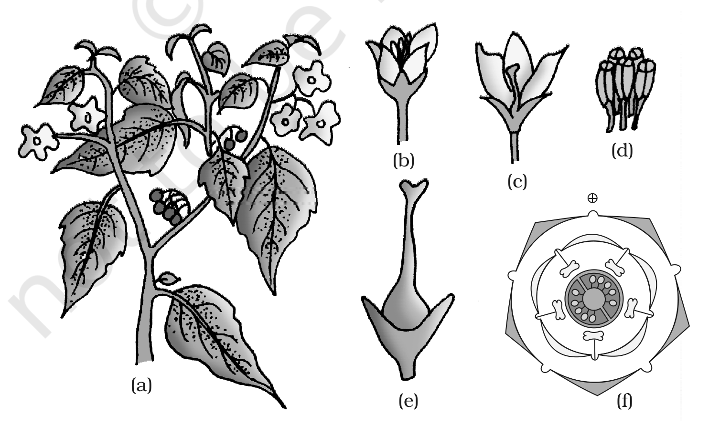
Fig. 5.17 - Solanum nigrum (makoi) plant : (a) Flowering twig (b) Flower (c) L.S. of flower (d) Stamens (e) Carpel (f) Floral diagram
Economic | Economic Importance

Many plants belonging to this family are source of food (tomato, brinjal, potato), spice (chilli); medicine (belladonna, ashwagandha); fumigatory (tobacco); ornamentals (petunia).
Recap | Quick Recap

- Flowering plants vary enormously in shape, size, structure, mode of nutrition, life span, habit and habitat, yet all have a root system and a shoot system.
- Root system is either tap root (majority of dicotyledons, e.g. mustard) or fibrous (monocotyledons, e.g. wheat); adventitious roots arise from parts other than the radicle. Roots absorb, anchor, store and synthesise growth regulators, and in some plants are modified for storage, mechanical support and respiration.
- The root tip runs root cap, region of meristematic activity, region of elongation, region of maturation, which bears the root hairs.
- Nodes and internodes, multicellular hair and positively phototropic nature distinguish the stem from the root.
- A leaf has leaf base, petiole and lamina; venation is reticulate (dicots) or parallel (monocots); leaves are simple or compound (pinnately or palmately); phyllotaxy is alternate, opposite or whorled.
- Inflorescence is racemose (axis grows on, flowers acropetal) or cymose (axis ends in a flower, flowers basipetal).
- The flower has four whorls on the thalamus: calyx, corolla, androecium, gynoecium. It may be actinomorphic, zygomorphic or asymmetric, and hypogynous, perigynous or epigynous, giving a superior, half inferior or inferior ovary.
- Aestivation is valvate, twisted, imbricate or vexillary. Placentation is marginal, axile, parietal, free central or basal.
- After fertilisation the ovary matures into a fruit and the ovules into seeds. A drupe such as mango or coconut has epicarp, mesocarp and endocarp.
- Dicotyledonous seeds have two cotyledons and may be endospermic or non-endospermous; monocotyledonous seeds are generally endospermic with a scutellum, coleoptile and coleorhiza.
- A plant is described in sequence - habit, vegetative characters, floral characters - and summarised as a floral diagram and floral formula, as illustrated by Solanaceae.

